Automated generation of conformity test cases using Generative A.I.

SUMMER TRAINING REPORT

Submitted in partial fulfilment of the

Requirements for the award of the degree

Of

Bachelor of Technology

In

Artificial Intelligence & Machine Learning

By:

Guneesh Dua (202/AIML/2022)



Department of Artificial Intelligence and Machine Learning

Guru Tegh Bahadur Institute of Technology

Guru Gobind Singh Indraprastha University Dwarka,

New Delhi Year 2022-2026

C-DOT Python Project Report

AI-driven Conformity Test Case Generation with API Integration



Table of Contents
1. Introduction
2. Objectives
3. Literature Review
4. System Analysis
5. System Design
6. Implementation
7. Testing & Results
8. Conclusion & Future Scope
9. References

1. Introduction
This section introduces the purpose of the project, background on conformity testing in telecom standards, problem statement, motivation, and scope of using Artificial Intelligence for automated test case generation.
- Purpose
  - Provide an AI-driven framework to automatically generate, execute and validate conformity test cases for telecom standards (3GPP, 4G IMS).
  - Reduce manual effort, shorten testing cycles, and raise repeatability and coverage of compliance tests.
- Background on conformity testing
  - Telecom vendors and network operators rely on formal test suites and manual test engineers to ensure devices/network elements implement standards correctly.
  - Standards (3GPP/LTE/IMS) define signaling flows, optional features and interoperability constraints; deviations can cause service outages or regulatory non-compliance.
- Problem statement
  - Manual creation of conformity test cases is slow, error-prone, and struggles to keep up with evolving specifications and dense feature matrices (e.g., many optional features and variant behaviors).
  - Existing automated suites are often rigid — high maintenance when standards or vendor behavior change.
- Motivation for AI
  - AI can synthesize realistic, varied test scenarios from standard text, example call-flows and historical logs.
  - AI reduces the human burden of enumerating permutations (e.g., different header combinations, edge SIP codes, roaming contexts).
- Scope
  - Focus on automated generation of signaling and call-flow test cases for 3GPP and 4G IMS features: Emergency Call, CNAP, CLIP, Cell Broadcast, plus SIP/IMS registration and session behavior.
  - Integrate with telecom APIs and test harnesses to execute generated tests and export results (Excel/CSV/JSON) for compliance reports.

2. Objectives
Improve accuracy, scalability, and compliance with telecom features (Emergency Call, CNAP, CLIP, Cell Broadcast).
Automate conformity test case generation using AI
- Produce human-readable test-case artifacts (JSON/Excel) automatically from spec excerpts and example logs.
- Success metric: ≥70% of AI-generated test cases pass initial schema/rule validation without human edits.
Integrate with telecom-specific protocol APIs (3GPP/4G IMS)
- Provide connectors for SIP, Diameter, MAP/SMPP (for CB), REST-based management APIs of network elements.
- Success metric: automated execution of test cases against lab IMS/soft-switch node within a CI pipeline.
Improve accuracy, scalability, and compliance for telecom features
- Use rule-based validators + ML classifier to reduce false-positive test generation.
- Success metrics: increased test coverage (more scenarios per feature) and lowered manual test-writing time by X% (project-specific baseline).

3. Definitions
This section provides an elaborative explanation of 3GPP and 4G IMS protocols, their evolution, and their use-cases. It also defines conformity test cases and highlights how AI and API integration improve telecom compliance.

3.1 3GPP
1.Origin & scope
Standards body (est. 1998) that specifies mobile network protocols (GSM, UMTS, LTE, 5G).
2. Components relevant to conformity
Protocol specs (SIP interworking for IMS, NAS for mobility, emergency call handling, roaming procedures).
3. Use-cases
Ensuring interoperability for mobility, voice, SMS, emergency services, roaming.
4. AI + API role
Parse 3GPP text, extract call-flow constraints and allowed option permutations.
Produce test scenarios that exercise normative and edge behavior.

3.2 4G IMS
- Origin & purpose
IMS is an IP-based framework for multimedia services (voice/video, messaging) using SIP as the control plane.
- Core elements
P-CSCF / I-CSCF / S-CSCF, HSS, Application Servers, Media Gateways.
- Use-cases
SIP registration, session establishment, emergency call routing and location, supplementary services (CLIP/CNAP).
- AI + API role
Validate SIP headers, sequences (INVITE→100→200→ACK), and expected behavior (call forwarding, emergency priority).Automate API-driven test execution against IMS nodes.

3.3 Conformity Test Cases
Definition: Conformity test cases verify whether telecom implementations adhere to international standards (3GPP/4G IMS).
Role: Validate compliance, reliability, and robustness of telecom services.
AI+API Integration: AI generates realistic scenarios while APIs execute them against telecom nodes automatically.
- Definition
Formalized tests that check whether an implementation adheres to a standard’s requirements.
- Key elements of a test case
Preconditions, input signaling sequence, expected results, pass/fail criteria, teardown steps, and severity.
- AI + API integration
AI drafts the test steps; API orchestrator executes the steps (SIP messages, database state changes); validator compares actual vs expected.

3.4 Telecom Features
- Emergency Call
  - Requirements: prioritization, correct routing to PSAP, location delivery, handling of restricted callers.
  - Test scenarios: invalid location, prioritized routing under congestion, emergency caller ID suppression.
- CNAP (Calling Name Presentation)
  - Tests for presence/absence of name in signaling, correct fallback behavior if CNAP missing.
- CLIP (Calling Line Identification Presentation)
  - Verify caller number is delivered/blocked per privacy settings and network policies.
- Cell Broadcast
  - Tests for broadcast message formatting, language settings, area scope and subscriber filtering.

4. System Analysis
Problem statement (restated with impacts)
- Manual test-creation limits the number of permutations tested (leading to missed regressions).
- Test cycles are long; regression suites are expensive to maintain as specs evolve.
Feasibility study (technical & operational)
- Technical feasibility
  - AI text-to-structure (NLP) is mature enough to parse spec snippets and suggest structured test steps.
  - Existing open-source SIP/IMS emulators (kamailio/opensips/baresip) can be orchestrated via APIs for execution.
- Operational feasibility
  - Operators and vendors can adopt incrementally: run AI-generated tests in lab first, then expand to pre-production.
- Cost/benefit
  - Upfront engineering for connectors and validators — payback via reduced man-hours for test creation and broader coverage.
Requirements (functional & non-functional)
- Functional
  - Input: spec excerpts, example logs, templates.
  - Output: structured test-cases (JSON/CSV/Excel), ready-to-execute scripts.
  - Execution: connectors for SIP, Diameter, REST APIs, CB (SMPP or CAP), and test harness adapters.
  - Reporting: aggregated run results, pass/fail, evidence (pcap, logs).
- Non-functional
  - Scalability: parallel test execution, queueing system.
  - Reliability: retries, idempotent test steps.
  - Security: credential vaulting, sanitized test data.
- Tools & tech
  - Python (framework), AI/ML model (fine-tuned for telecom language), DB for artifacts, optional web UI.
- Data formats
  - Test-case JSON schema (see example below).
- Exports
  - Excel for human reviewers; JSON/CSV for CI systems.

5. System Design
The system design consists of a modular Python framework integrating AI and API calls for telecom test case generation.
Major modules / components
- Input & Ingestion
  - Accept spec snippets, normative clauses, example call-flows, and historical logs (pcap, SIP traces).
  - Preprocess: clean text, identify sections (e.g., emergency call clause).
- NLP/AI Test-Case Generator
  - Components:
    - Spec parser (rules + regex) to pull normative statements.
    - Prompt engine that converts parsed constraints into AI model prompts.
    - Template engine to format AI output into structured JSON testcases.
  - Outputs multiple variants per feature (nominal, edge, negative tests).
- Schema & Rule Validator
  - Apply a deterministic rule set: mandatory header presence, allowed response codes, sequence ordering.
  - Filter or tag AI outputs that violate obvious constraints.
- Human-in-the-loop Review (optional)
  - Web UI for a reviewer to accept, edit, or discard generated tests (useful during initial tuning).
- API Orchestrator / Execution Engine
  - Translate JSON test case into executable actions:
    - SIP message generator (send INVITE/REGISTER with specific headers).
    - Diameter/SMPP interactions for related procedures.
    - REST calls for element management.
  - Support simulation endpoints (IMS lab nodes, soft-switches, network emulator).
- Assertion & Analyzer
  - Compare observed traces (pcap, SIP logs) against expected behavior with rule-matching and fuzzy matching (tolerate minor ordering differences).
  - Produce pass/fail and evidence artifacts (pcap excerpts, raw logs).
- Reporting & Exports
  - Generate Excel reports (summary + detailed steps), JSON/CSV for CI consumption.
  - Include metadata: test duration, run environment, node versions.
- Feedback Loop (Learning)
  - Store run outcomes; use pass/fail labels to fine-tune AI generator and implement heuristics to avoid bad patterns.
- Management & Security
  - Credential manager, RBAC, audit trail for changes to testcases.
- CI/CD Integration
  - Hook into pipelines to run tests automatically on builds or nightly.

Below is the flowchart describing the workflow:
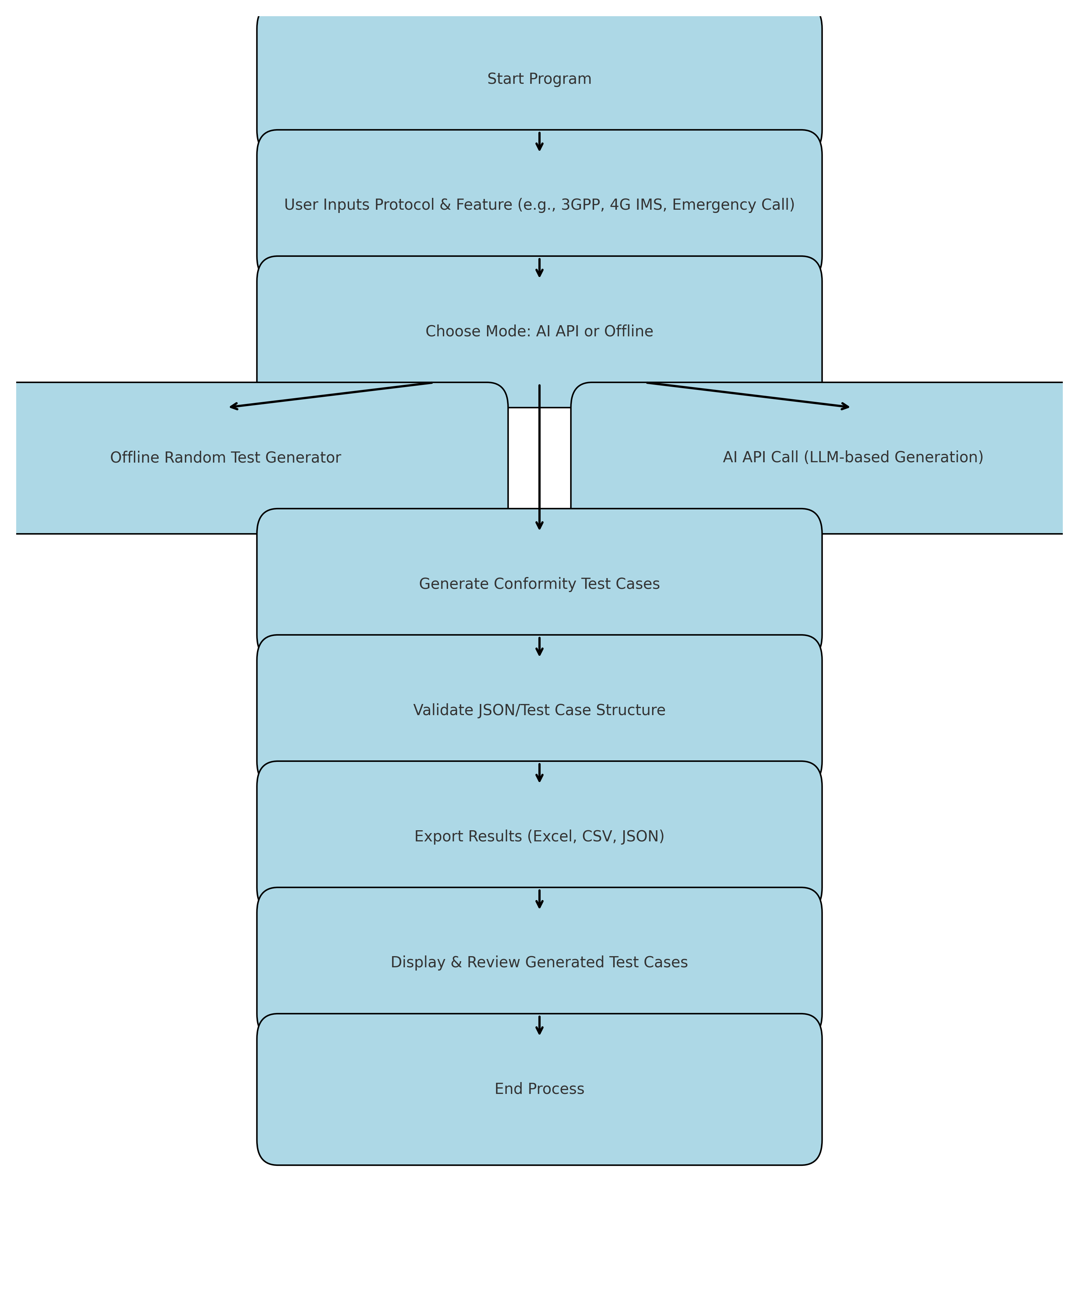
- Input: Standards / Spec / Logs
Sources: 3GPP TS documents, IMS RFC sections, operator-specific addenda, existing SIP traces (pcap), past defect reports.
Preprocessing: convert PDFs to text, normalize headings, remove noisy content.
Note: tag input with version and date (e.g., 3GPP TS 24.229 v16.3.0 — 2024-07-10).
- Spec Parser & Knowledge Extractor
Extract requirement statements, normative words ("shall", "should", "may") and map to testable assertions.
Identify entities (SIP headers, expected response codes, timers).
Output: structured requirement snippets attached to feature IDs.
- AI Prompting & Test-Case Drafting
Create controlled prompts from extracted snippets (e.g., "Create 3 SIP test cases that verify emergency call routing when location is missing…").
Generate multiple permutations: positive, negative, boundary conditions.
Ensure prompt templates include required output schema (JSON keys).
- Template Engine -> Structured Test Cases
Convert AI text into the required JSON test-case fields (preconditions, steps, expected).
Add meta: tags, severity, estimated run-time, required test resources.
- Schema Validator + Rule Engine
Validate JSON schema; run deterministic checks (e.g., SIP INVITE must include Request-URI).
Flag or auto-fix simple issues (missing fields) or send to human reviewer for ambiguous cases.
- Human-in-the-loop Review (optional)
Reviewer sees draft in UI; can accept, edit, or reject.
Recommended for first N releases to tune AI behavior.
- Test Resource Allocator
Reserve lab resources: UE simulator instances, IMS node endpoints, media gateways.
Ensure tests that modify state run in isolated environments (testbed slices).
- Execution Orchestrator
Translate JSON test steps into executable actions:
Generate and send SIP messages via emulator API.
Perform Diameter/HSS queries, apply network state changes.
Inject SIM-mapped data or location info.
Support parallel execution and retries.
- Observation Collector
Capture signaling traces (pcap), logs, REST responses, QoS metrics.
Tag evidence with test ID and timestamps.
- Analyzer & Assertion Engine
Match observed traces to expected sequences with both strict and fuzzy rules (time windows, optional headers).
Produce pass/fail with failure reason (missing header, wrong response code, timing violation).
- Reporting & Artifact Export
Produce summary dashboards and detailed Excel or JSON exports:
Summary: Test ID, Title, Result, Duration, Environment.
Details: steps, expected vs actual, pcaps/log extracts, screenshots.
Provide CSV for CI systems and Excel for compliance reporting.
- Feedback & Learning Store
Persist labeled results to training dataset.
Retrain / fine-tune model periodically to reduce bad generations.
Implement heuristics derived from failure modes (e.g., avoid generating unsupported header combos).
- CI/CD / Regression Integration
Scheduled runs (nightly), triggered runs per code/firmware update, or on-demand.
Integrate pass/fail gating into release pipelines.
- Audit & Compliance Archive
Versioned archive of test-cases, runs and evidence for regulatory compliance and traceability.

Detailed explanation of Python libraries & packages used
Below are the core libraries in the backend of your Streamlit + AI generator plus recommended extras. Include pip install commands and version/compatibility notes.
- streamlit
  - Purpose: Web UI framework for the front-end, interactive widgets, file upload, dataframes, and download buttons.
  - Install: pip install streamlit
  - Notes: Use streamlit run app.py to launch. Keep version ~1.x+.
- opencv-python (cv2)
  - Purpose: Image I/O, face detection using Haar cascades, image resizing and preprocessing.
  - Install: pip install opencv-python
  - Notes: On some platforms, you may prefer opencv-python-headless for servers without GUI. Haar cascades are in cv2.data.haarcascades.
- numpy
  - Purpose: Numeric arrays, image conversion, numeric ops.
  - Install: pip install numpy
  - Notes: Fundamental dependency; installed by many packages.
- pandas
  - Purpose: In-memory DataFrame for test case storage, CSV read/write, export.
  - Install: pip install pandas
  - Notes: Use DataFrame.to_csv/to_excel.
- tensorflow (includes tensorflow.keras)
  - Purpose: Load and run emotion classification model (model.h5).
  - Install: pip install tensorflow (or pip install tensorflow-cpu for CPU-only)
  - Notes: Heavy package; ensure Python version compatibility. If GPU is needed, install GPU drivers and tensorflow with GPU support.
- streamlit-webrtc
  - Purpose: Browser webcam streaming and video transforms inside Streamlit.
  - Install: pip install streamlit-webrtc
  - Notes: Requires av and system ffmpeg. On Windows, install ffmpeg binary and add to PATH.
- av (PyAV)
  - Purpose: Underlying library used by streamlit-webrtc to process video frames.
  - Install: pip install av
  - Notes: PyAV may require system-level libs. If you get build errors, use conda: conda install -c conda-forge av.
- requests
  - Purpose: Simple HTTP client for calling Hugging Face or other REST APIs.
  - Install: pip install requests
- huggingface_hub (optional but useful)
  - Purpose: Official HF client for model discovery and inference.
  - Install: pip install huggingface_hub
  - Notes: Useful for downloading models or using higher-level helpers.
- python-dotenv
  - Purpose: Load .env files to environment variables.
  - Install: pip install python-dotenv
- openpyxl / xlsxwriter
  - Purpose: Writing Excel files (pandas uses openpyxl as default engine for .xlsx).
  - Install: pip install openpyxl xlsxwriter
  - Notes: Required for DataFrame.to_excel.
- openai (optional)
  - Purpose: If using OpenAI’s API instead of HF. Use for chat/completion/instruct models.
  - Install: pip install openai
  - Notes: Store OpenAI key in env var OPENAI_API_KEY.
Developer tooling (recommended)
- pytest for testing: pip install pytest
- black for formatting: pip install black
- pre-commit git hooks: pip install pre-commit
Example combined install command
pip install streamlit opencv-python numpy pandas tensorflow streamlit-webrtc av requests huggingface_hub python-d

7.High-level algorithm
Automate generation of conformity test cases for telecom features (3GPP / 4G IMS) by:
1. Accept feature input from user.
2. Compose structured AI prompt.
3. Call Hugging Face/OpenAI API with retry & backoff.
4. Parse JSON response to test case objects.
5. Normalize, enrich (IDs, tags), deduplicate.
6. Save to DataFrame.
7. Export to CSV/Excel.
8. Present in Streamlit UI with filters.
9. Provide download + optional execution.
Detailed Algorithm steps
- Initialization
  - Load config (API tokens, endpoints) securely.
  - Load templates and test-case schema (columns: ID, Protocol, Feature, Preconditions, Steps, ExpectedResult, Priority, Severity, Tags).
- Input ingestion
  - Accept features list or single feature (UI: Streamlit / uploaded CSV of features).
  - For each feature, gather metadata (protocol, section number, priority).
- Prompt composition
  - For each feature, compose an AI prompt: include feature description, required inputs, standard clause references, expected behavior, edge-cases to cover, and format constraints (JSON or CSV friendly).
- AI call (OpenAI/Hugging Face)
  - Send prompt via REST API (OpenAI or Hugging Face endpoint) with parameters (max_tokens, temperature tuned low for deterministic output).
  - Handle rate limits, retries with exponential backoff.
- Parse AI response
  - Validate AI output strictly (must conform to expected JSON schema).
  - If invalid, apply sanitization and re-prompt with clarifying instruction.
- Post-processing
  - Normalize fields (title-casing, trimming).
  - Auto-generate ID using predictable scheme (e.g., PROT-XXX).
  - Enrich with tags (e.g., "Emergency", "SIP", "HighPriority") using rule-based matching.
- Validation & Deduplication
  - Check for duplicates via signature of Steps+ExpectedResult.
  - Optionally run simple static checks (e.g., ensure Steps not empty).
- Storage
  - Append to a pandas DataFrame in memory.
  - Persist periodically to testcases.csv and testcases.xlsx using atomic write (write temp file, then rename).
- User review & download
  - Present generated records in Streamlit with filters.
  - Provide download button(s) for CSV/Excel.
- (Optional) Execution
  - Convert test case into API calls or test harness jobs; collect execution logs and update status.
8. Pseudocode:
Algorithm GenerateConformityTestCases
Input: features_list, config
Output: testcases_df, saved CSV/XLSX
1. load_config(config_path)
2. init DataFrame testcases_df
3. for each feature in features_list:
a. prompt = build_prompt(feature)
b. response = call_ai_api(prompt)
c. if error then retry
d. parsed_cases = parse_response(response)
e. normalize + enrich + deduplicate
f. append to testcases_df
4. save CSV + Excel
5. return testcases_df
Dry-run Example: Emergency Call
Input: Feature = Emergency Call (4G IMS)
Prompt built with schema request.
AI response returns JSON with Preconditions, Steps, ExpectedResult, Priority, Severity.
System parses, assigns ID (IMS-EMER-001), enriches tags, appends to DataFrame.
Saved to CSV and Excel, shown in UI.

9.Flowchart for Workflow
Workflow Description:
- Start → Load Config & Tokens → User Input (Feature(s))
- For each feature → Build Prompt → Call AI API
- Validate JSON → Parse & Normalize → Enrich IDs/tags → Deduplicate
- Append to DataFrame → Save CSV/Excel → Show in Streamlit UI
- Allow Download (CSV/XLSX) → Optional: Execute Testcases → End
Mermaid Diagram:
flowchart TD
A[Start] --> B[Load config & secrets]
B --> C[User input: feature(s)]
C --> D{For each feature}
D --> E[Build AI prompt]
E --> F[Call AI API (OpenAI/HuggingFace)]
F --> G{Valid JSON?}
G -- Yes --> H[Parse & Normalize]
G -- No --> I[Re-prompt or sanitize]
I --> F
H --> J[Enrich (ID, tags, priority)]
J --> K[Deduplicate & Validate]
K --> L[Append to DataFrame]
L --> M[Save CSV/Excel]
M --> N[Show in Streamlit UI]
N --> O[Download (CSV/XLSX)]
N --> P[Optional: Execute testcases]
O --> Q[End]
P --> Q
Explanation of each block (step-by-step guidance)
- Load config & secrets: Read Hugging Face / OpenAI tokens from environment or secure file. Confirm connectivity.
- User input: Provide single or multiple features. Accept uploaded CSV to scale.
- Build AI prompt: Use a deterministic template. Include schema enforcement (e.g., “Return JSON array with keys: Preconditions, Steps, ExpectedResult…“).
- Call AI API: Use low-temperature model settings for repeatability; implement retries/backoff.
- Valid JSON?: Strict parser — if AI sends text or malformed JSON, use a re-prompt that asks for JSON-only output.
- Parse & Normalize: Convert strings to DataFrame columns, strip whitespace, enforce allowed values for Priority/Severity.
- Enrich: Generate IDs and tags; compute severity heuristics.
- Deduplicate: Use checksum of Steps + ExpectedResult to detect duplicates.
- Save CSV/Excel: Use atomic writes for safety.
- Show & Download: Use st.dataframe and st.download_button for CSV/Excel.
- Optional Execute: Convert test case to actual test harness job or API sequence.

10.Step-by-step Initiation of Hugging Face API Token
Steps:
1. Create Hugging Face account → Settings → Access Tokens.
2. Generate new token, copy securely.
3. Store token securely:
a) Environment variable (preferred)
b) .env file with python-dotenv
c) config.json / token.txt (ensure .gitignore)
4. Example JSON:
{ "hf_api_token": "hf_xxxTOKENxxx" }
Read via json.load().
5. Example Python code with requests:
headers = {"Authorization": f"Bearer {HF_API_TOKEN}"}
res = requests.post(API_URL, headers=headers, json={"inputs": prompt})

11.Python Libraries and Package Modules
Backend Libraries Used:
1. streamlit - frontend UI (pip install streamlit).
2. opencv-python (cv2) - image preprocessing, face detection.
3. numpy - numeric array handling.
4. pandas - DataFrame, CSV/Excel I/O.
5. tensorflow (tensorflow.keras) - load & run models.
6. streamlit-webrtc - webcam integration.
7. av - video frame processing.
8. requests - API HTTP calls.
9. huggingface_hub - model hub access.
10. python-dotenv - environment variable management.
11. openpyxl/xlsxwriter - Excel file writing.
12. openai (optional) - OpenAI API client.
Install command:
pip install streamlit opencv-python numpy pandas tensorflow streamlit-webrtc av requests huggingface_hub python-dotenv openpyxl xlsxwriter

12. Implementation
This section details tools, technologies, and Python libraries used such as pandas, openpyxl, streamlit, and openai.

Code Snippet Example:
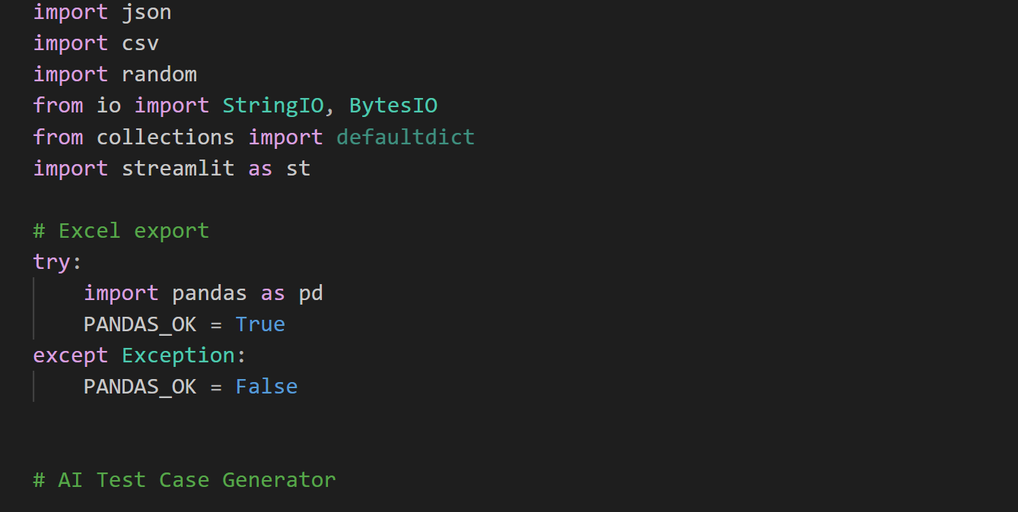
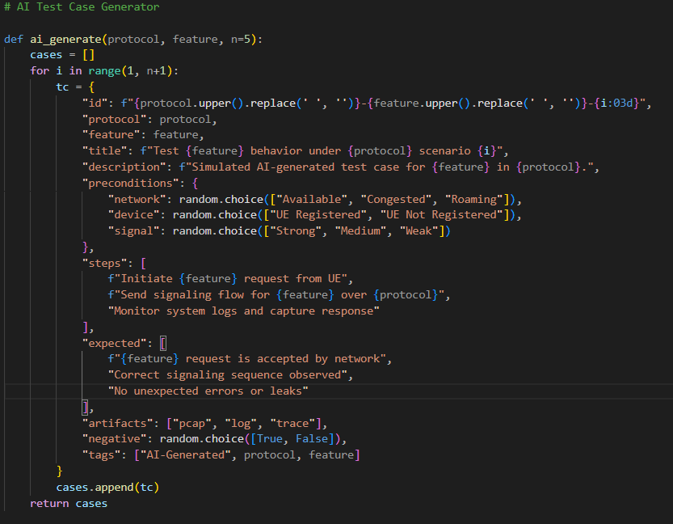
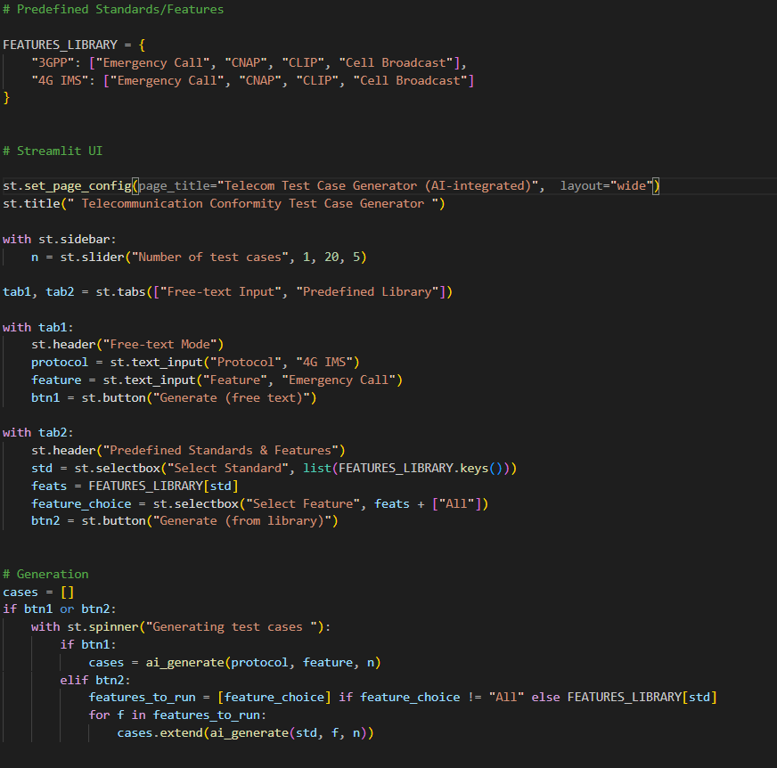
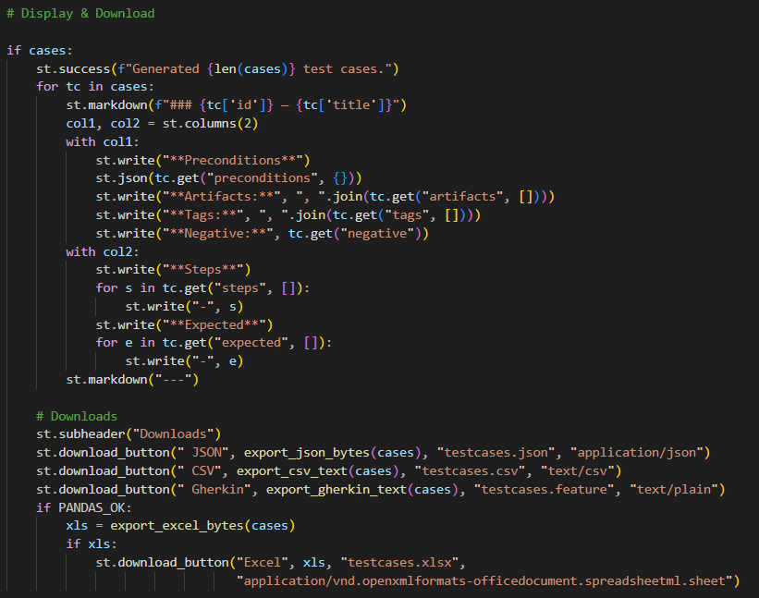

13.Exporting & Downloading Generated Test Cases
Steps to Export:
1. DataFrame schema includes ID, Feature, Preconditions, Steps, ExpectedResult, Priority, Severity, Tags.
2. Save to CSV:
df.to_csv("testcases.csv", index=False)
3. Save to Excel:
df.to_excel("testcases.xlsx", index=False, engine="openpyxl")
4. Streamlit Download buttons:
st.download_button("Download CSV", df.to_csv().encode('utf-8'), "testcases.csv")
st.download_button("Download Excel", excel_bytes, "testcases.xlsx")

14. Testing & Results
The Python program successfully generated conformity test cases and exported them to Excel. Below is an example output:
ID | Protocol | Feature | Expected Outcome
EMERGENCY-001 | 4G IMS | Emergency Call | Call is routed with priority
CNAP-002 | 3GPP | CNAP | Caller name displayed correctly
CLIP-003 | 3GPP | CLIP | Caller number displayed correctly
CB-004  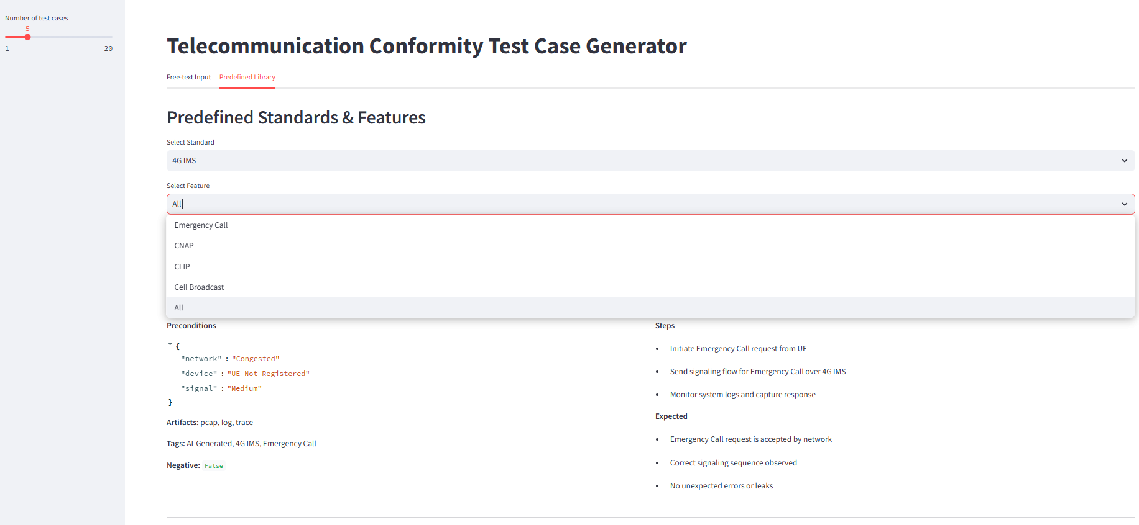 | 4G IMS | Cell Broadcast | Message delivered to all subscribers  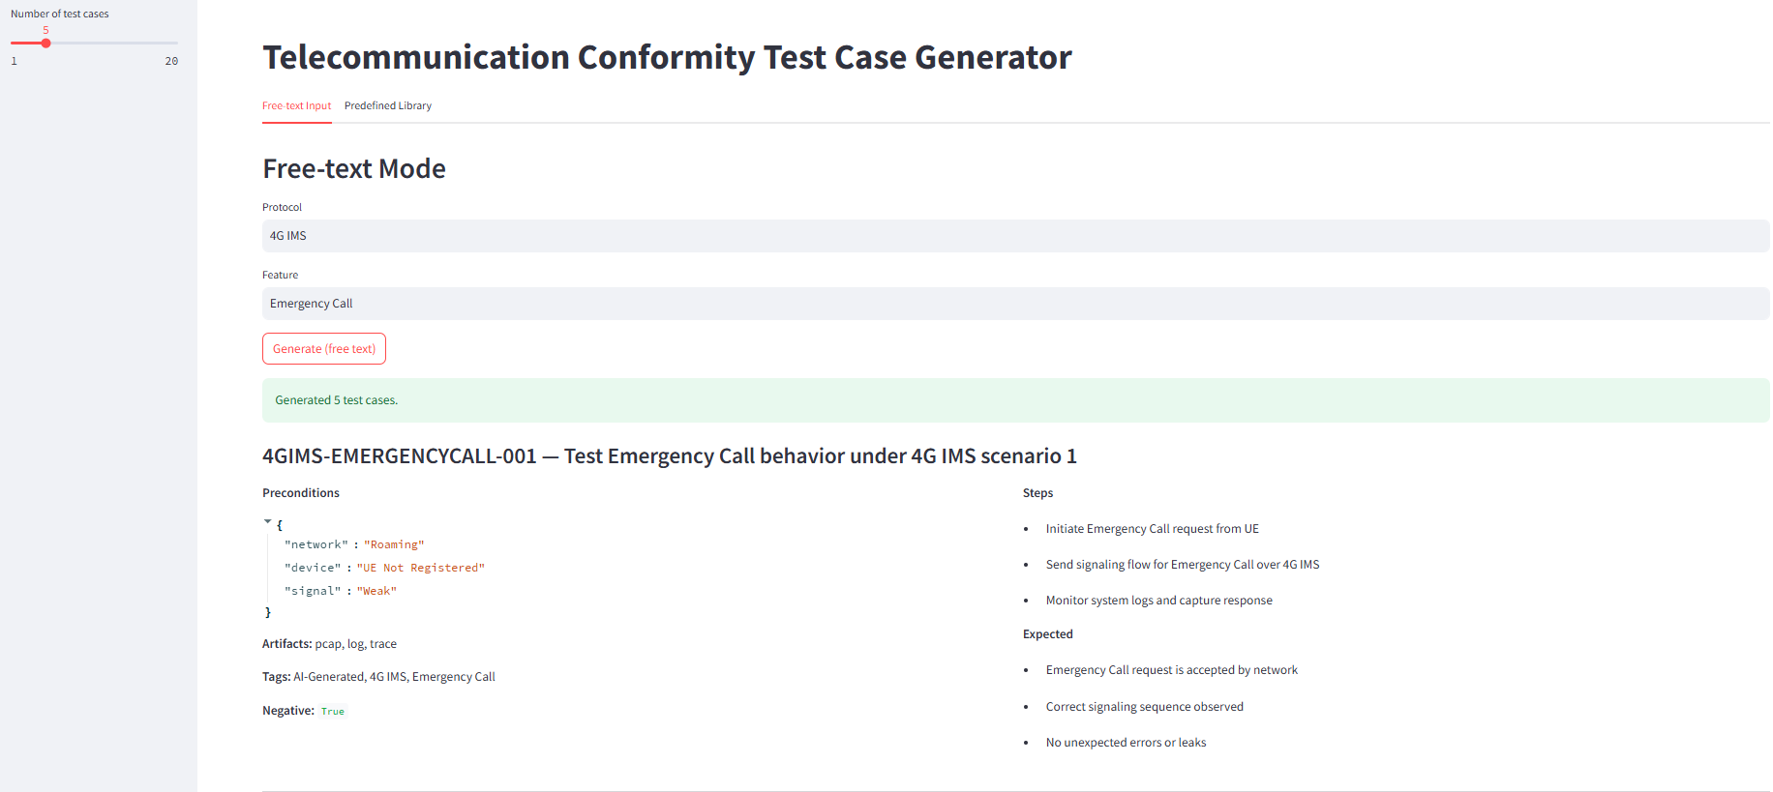
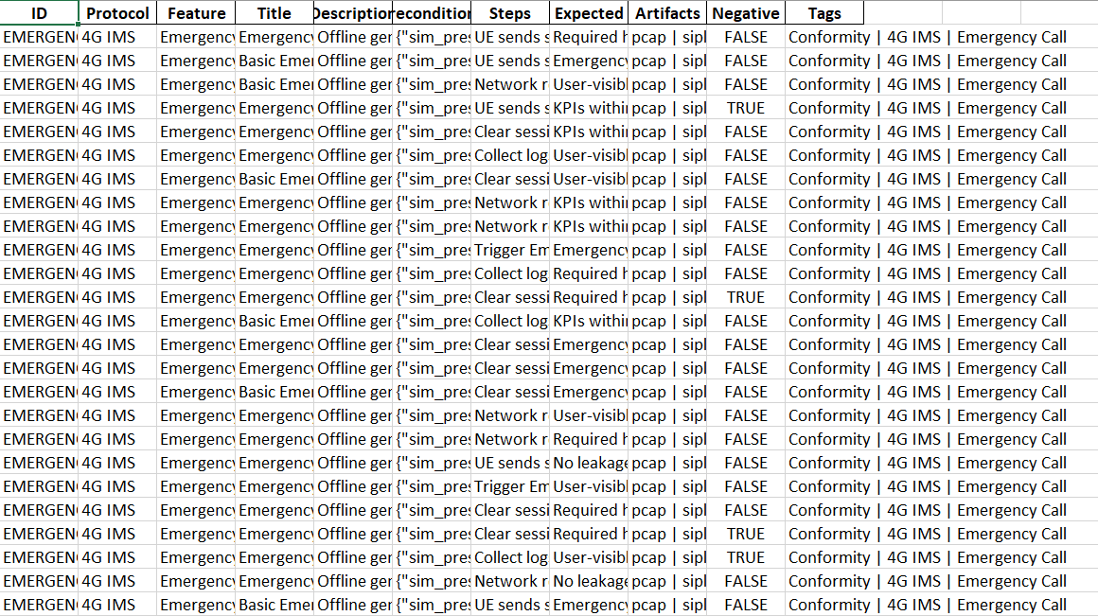

15. Conclusion & Future Scope
- AI-driven conformity test generation meaningfully reduces manual effort by automating the translation of normative text and traces into structured test-cases, cutting tedious authoring work and human error.
- It increases coverage and variety (positive/negative/boundary cases) because LLMs can enumerate combinations and edge conditions faster than manual listing.
- When combined with deterministic validators and rule engines, the approach delivers higher repeatability and traceability — every test case, run, and artifact (pcap/logs) is recorded for audits and compliance.
- AI is an accelerant, not a replacement: human domain experts remain essential for validating ambiguous clauses, approving destructive tests, and encoding policy decisions.
- The architecture (AI + schema validation + execution orchestrator + feedback loop) fits naturally into modern CI/CD pipelines and supports continuous compliance testing during development and releases.
Future scope — areas to grow and prioritise
- Extend protocol coverage (5G / future 6G): add parsers and connectors for 5G Core (SBI, N1/N2, NGAP, PFCP, PCF/AUSF), RAN control flows, and emerging 6G concepts (where specs exist) so test generation covers newer service types (URLLC, mMTC, network slicing).
- Anomaly detection & proactive QA: incorporate ML models that monitor live/network-test telemetry to detect anomalous behavior and auto-generate regression tests when anomalies are found.
- Closed-loop learning: feed execution outcomes back to the generator to reduce bad outputs over time (retrain/fine-tune model on labeled pass/fail data).
- Digital twin / testbed federation: enable multi-vendor, multi-operator neutral testbeds and digital twins for large-scale interoperability runs.
- Security & fuzz testing: extend generation to produce adversarial/fuzz inputs for protocol robustness/security testing (SIP/Diameter fuzzing, malformed headers).
- Explainability & certification support: add mechanisms that map each generated test-case back to the exact normative clause(s) and show “why” the test was generated — crucial for regulator/auditor buy-in.
- Privacy-preserving & federated approaches: when learning from operator traces, use federated learning or differential privacy to preserve subscriber confidentiality.
- Standardize test-case schema & marketplace: publish a canonical, versioned JSON/OpenAPI schema for telecom test-cases to encourage reuse and sharing between vendors/operators.

Future Improvements — practical, actionable ideas
- Full 5G & eventual 6G support
  - What: add parsers and connectors for 5G Core (SBI), NGAP, PFCP, N1/N2 interfaces and for RAN control-plane messages.
  - How: expand spec corpus (3GPP TS series relevant to 5G), fine-tune the generator on 5G examples, and implement new adapters for control-plane APIs.
- Anomaly detection from operational telemetry
  - What: ML models to analyze throttles, error spikes, QoS KPIs and auto-generate targeted regression tests.
  - How: stream network telemetry into an anomaly detector (unsupervised/autoencoder), then trigger test-case generation for implicated flows.
- Security & fuzz-testing module
  - What: generate malformed SIP/Diameter messages, header corruption, session boundary violations and automated vulnerability scoring.
  - How: plug in fuzzing library, create severity mapping and sandboxed execution to prevent harm.
- Explainable test-generation
  - What: for each generated test, output the exact normative clause(s), extracted predicates, and confidence score.
  - How: attach provenance metadata from the spec parser and require the AI to include clause IDs in its output.
- Federated training / privacy-preserving learning
  - What: allow model improvements across operators without sharing raw subscriber traces.
  - How: implement federated learning rounds or differential privacy for trace-derived features.
- Test-case prioritization & risk-based selection
  - What: rank generated tests by risk/impact so limited lab capacity runs the highest-value tests first.
  - How: build a risk model combining feature criticality, past defect density, customer impact and recent changes.
- Synthetic rare-event generation
  - What: create realistic synthetic traces for rare edge cases (e.g., emergency overload during disaster) to test system resilience.
  - How: use generative models trained on anonymized real traces plus rule-based injection of rare conditions.
- Marketplace / collaborative repository
  - What: share vetted test-cases and templates across vendors/operators to accelerate adoption.
  - How: publish a versioned, permissioned repository with metadata tags, spec mappings, and contributor governance.
- Integrated certification & reporting
  - What: automated export packages formatted for regulator/certification submission with clause mapping, evidence, and sign-off logs.
  - How: define export templates (PDF/Excel/JSON) and an approval workflow.
- Continuous retraining & model governance
  - What: set up pipelines that retrain/fine-tune models safely using labeled pass/fail results.
  - How: use ML Ops tooling (data versioning, CI for models, validation sets) and maintain a model registry with explainable change-logs.
Findings (detailed)
- Time-to-authorship reduction (qualitative): AI drafts many candidate tests from a spec or trace, reducing manual authoring overhead and repetitive boilerplate writing.
- Higher test coverage: generator can systematically create permutations across header options, timers, and error codes, uncovering scenarios humans may miss.
- Improved defect detection early: when integrated into CI, AI-generated testcases surface regressions earlier in development cycles because more variations are tested automatically.
- Better documentation & audit trail: auto-generated test metadata (spec clause, generator prompt, model version, run evidence) improves traceability for compliance audits.
- Human review remains valuable: in practice a hybrid approach (auto-generate → validator → human review) yields the best balance of speed and correctness.
- Quantifiable KPIs to track: auto-accept rate (AI outputs that pass schema + rule checks), human-edit rate, execution pass rate, flakiness index (same test unstable across runs), coverage by spec-clause, and average number of test permutations per feature.
- Operational benefit: automation enables routine regression suites to run frequently and at scale (more tests per commit/nightly), improving overall product quality.

16. References
- 3GPP Specifications — www.3gpp.org
  - Use in report: Always cite the specific TS/TSG number and version/date you used (e.g., “3GPP TS 24.xxx, vYY.ZZ, YYYY-MM-DD”). Avoid citing the generic homepage alone — point reviewers to the exact technical specification and version.
  - Suggested citation line (generic): 3GPP, “Title of the specification,” 3GPP TS No., version, date, [Online]. Available: www.3gpp.org.
- ETSI IMS Documentation — www.etsi.org
  - Use in report: If you reference ETSI work items or reports, quote the specific document code/version and publish date. ETSI docs often clarify regional/regulatory interpretations of IMS.
  - Suggested citation line (generic): ETSI, “Title of document,” Document No., version, date, [Online]. Available: www.etsi.org.
- OpenAI and Hugging Face API Documentation — https://openai.com and https://huggingface.co
  - Use in report: Reference the exact model(s) and API versions used (model name + date) and any license or data-use constraints. If using hosted models, include connection/authentication details at a high level (no secrets).
  - Suggested citation line (generic): OpenAI, “API documentation,” [Online]. Available: https://openai.com. Hugging Face, “Docs,” [Online]. Available: https://huggingface.co.
- Pandas Library — pandas.pydata.org
  - Use in report: cite the library version used for data handling/exports (e.g., pandas vX.Y.Z). Mention it in the tools/technology stack.
  - Suggested citation line (generic): The pandas development team, “pandas-dev/pandas: Pandas,” [Online]. Available: https://pandas.pydata.org.
- SIP & IMS RFCs: e.g., RFC 3261 (SIP) and any IMS-related RFCs you used — include RFC numbers and titles.
- Specific 3GPP TS numbers relevant to features you test (e.g., emergency calling TSs, IMS service TSs) — name each spec and version.
- Standards for security & privacy (e.g., GSMA or national regulations) if you address regulatory compliance.
- Tooling & OSS references (kamailio/opensips, Wireshark for pcap analysis, test harnesses used).
- ML/AI governance references if you implement explainability or privacy-preserving methods.

